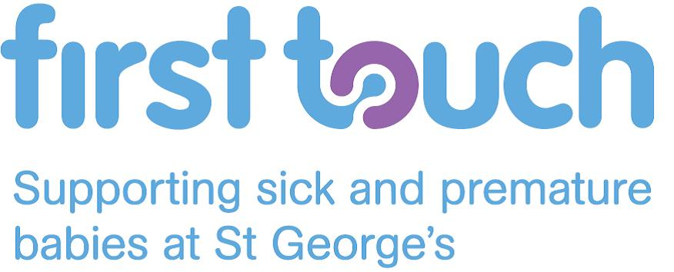
Charity Gift Aid Declaration
Boost your donation by 25p of Gift Aid for every £1 you donate

Gift Aid is reclaimed by the charity from the tax you pay for the current tax year. Your home address is needed to identify you as a current UK taxpayer.
In order to Gift Aid your donation you must tick this box □

I want to Gift Aid my donation of £______________ and any donations I make in the future or
have made in the past 4 years to FIRST TOUCH

I am a UK taxpayer and understand that if I pay less Income Tax and/or Capital Gains Tax than
the amount of Gift Aid claimed on all my donations in that tax year it is my responsibility to pay any
difference.

My Details
Title ____________________ First name or initial(s) ________________________________
Surname _____________________________________________________________________
Full Home address _____________________________________________________________
_____________________________________________________________________________
_____________________________________________________________________________
Postcode __________________________ Date ______________________________________
Please notify the charity if you:
- want to cancel this declaration
- change your name or home address
- no longer pay sufficient tax on your income and/or capital gains

If you pay Income Tax at the higher or additional rate and want to receive the additional tax relief
due to you, you must include all your Gift Aid donations on your Self-Assessment tax return or ask
HM Revenue and Customs to adjust your tax code.

Please return your form to:
First Touch
NNU, First Floor Lanesborough Wing
St George’s Hospital
Blackshaw Road
London
SW17 0QT

